1. Paper 5th: “A visual Validation Method Based on Point Mappings for Medical Image Segmentation”

What is the different of each color in the image below?

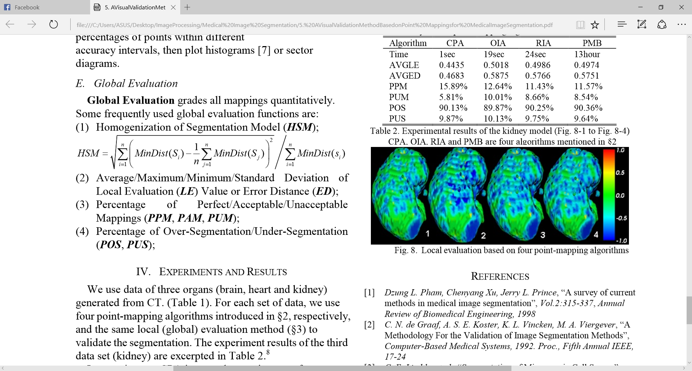

Before answer this question, I would like to give some background information about this research work. This research in working on validation method which based on point mapping for segment medical image. In the paper talked about there are thousands of segmentation method but for this validation have only tens and can be classified into 4 groups such as: no validation, quantitative analysis, global quantitative experiment and local quantitative experiment. This work is worked on full automatically visual validation based on (both local and global) quantitative experiments. Back to image above is the segmentation based on Local quantitative experiment which used in 4 different algorithms (CPA, OIA, RIA, and PMB). The color represent to RGB which is divide into 3 parts such as

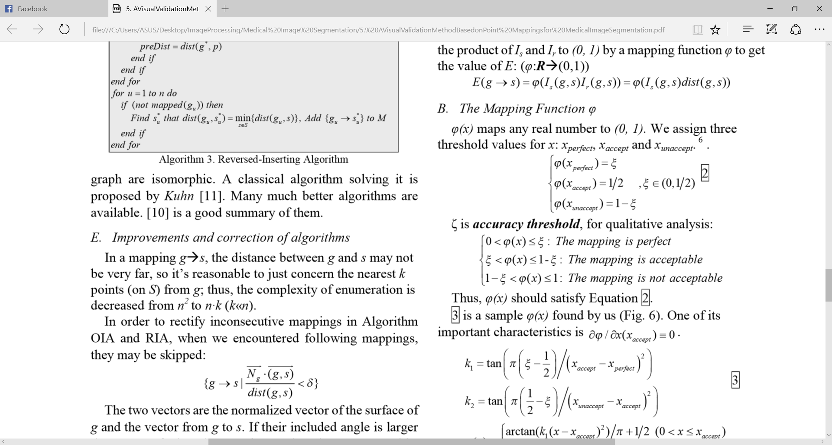

Thus the red color in represent the perfect mapping, the green is presented the acceptable and blue represent the unacceptable.

1. Paper 6th “V-Net: Fully Convolutional Neural Networks for Volumetric Medical Image  
   Segmentation”

Question: What is the different between ANN and CNN?

CNN: **Convolutional Neural Networks** is the learning single global weight matrix between two layers, they aim to find a set of locally connected neurons. CNNs are mostly used in image recognition. Their name comes from "convolution" operator or simply "filter". In short, filters are an easy way to perform complex operation by means of simple change of a convolution kernel. Apply Gaussian blur kernel and you'll get it smoothed. Apply Canny kernel and you'll see all edges. Apply Gabor kernel to get gradient features. Image below show global weight matrix between two layers:

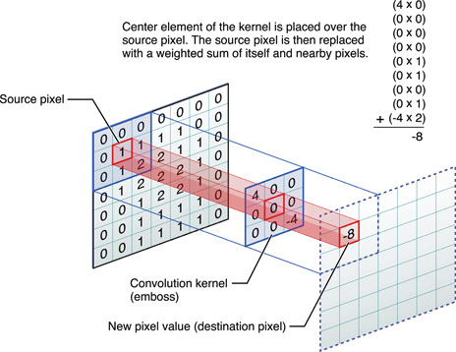

Reference: http://stats.stackexchange.com/questions/114385/what-is-the-difference-between-convolutional-neural-networks-restricted-boltzma

While   
ANN: **Artificial neural networks** (**ANNs**) are a computational model used in computer science and other research disciplines, which is based on a large collection of simple neural units (artificial neurons), loosely analogous to the observed behavior of a biological brain's axons. Each neural unit is connected with many others, and links can enhance or inhibit the activation state of adjoining neural units. Each individual neural unit computes using summation function. There may be a threshold function or limiting function on each connection and on the unit itself, such that the signal must surpass the limit before propagating to other neurons. These systems are self-learning and trained, rather than explicitly programmed, and excel in areas where the solution or feature detection is difficult to express in a traditional computer program.

In conclusion, the different between ANN and CNN are:

-ANN methodology based on neural unit (artificial neuron) while CNN use Convolution or filter operator.

-ANN have neural unit which each neural unit computer use summation function (threshold function of limitation function) while in CNN have use convolution operator to different kernel such as Gaussian Blur kernel, apply Gabor kernel or Canny kernel.

1. paper 8th “Weighted Level Set Evolution Based on Local Edge Features for Medical Image Segmentation”.

Question: What is the different between local and global feature?

The different is:

Global features describe the image as a whole to the generalize the entire object. Global features include contour representations, shape descriptors, and texture features. Shape Matrices, Invariant Moments (Hu, Zerinke), Histogram Oriented Gradients (HOG) and Co-HOG are some examples of global descriptors.

Local features describe the image patches (key points in the image) of an object. SIFT, SURF, LBP, BRISK, MSER and FREAK are some examples of local descriptors.

Generally, for low level applications such as object detection and classification, global features are used and for higher level applications such as object recognition, local features are used. Combination of global and local features improves the accuracy of the recognition with the side effect of computational overheads.

Reference: <https://www.quora.com/Computer-Vision-What-is-the-difference-between-local-descriptors-and-global-descriptors>

1. paper 10th “Image Segmentation Techniques and its applications for Knee Joints: a Survey”

Question: what is the different between region growing and region spiting?

The different between region growing and region spitting is:

Region growing is a segment method hic based on seed point then growing with the same pixel when it reach the different pixel it will stop by adding Heuristics when to stop growing

– Gradient Magnitude • |f(x,y) – f(n8)| < T && f(n8) < Tm

– Edge Boundary

• Run a canny detector

•If a point is on a boundary, it can’t be added to the region

– Application specific

Some example of similarity measure to pixel:

Use original seed, Boundary Neighbors, Region Statistics, Multiple Seeds and Counterexamples

While   
 Region Spiting is based smaller region which is gotten form the divide of larger region then combine all the same smaller region by using squad tree. In other words, we can say region spitting methodology will be followed this step:

Split the image into regions

If the entire region doesn’t satisfy the predicate P(Ri)

– split it into smaller regions

– repeat

Use the quad-tree data structure

**Quad Tree**

• Data Structure

– Each root has 4 children

– Encodes a 2D spatial relationship

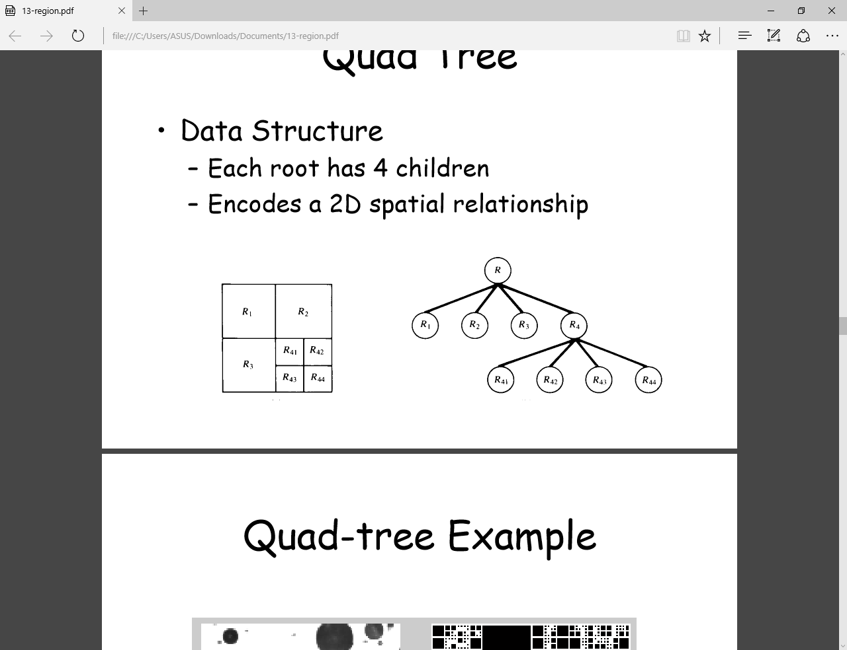

1. Paper 11th “Automatic Bone Segmentation and Alignment From MR Knee Images”

Explain: Alignment, what is T1 & T2?, the price of MRI and X-ray in Thailand.

1. The price of MRI and X-ray in Thailand.

MRI the price around 7000 – 8000 bth, Ref: http://www.thaivisa.com/forum/topic/193196-hospital-prices-for-mri-scan/

X-ray the price around 200 -300 bht, ref: <http://www.whatclinic.com/diagnostic-imaging/thailand/medical-x-ray>

1. What is T1 and T2 in the research paper?

**T1 relaxation** is measured using a time constant called T1 (usually reported in milliseconds, msec). **T1** is defined as the time when 63% of the longitudinal magnetization has recovered; 3 x T1=95% recovery.

**T2 relaxation** is measured using a time constant called T2 (usually reported in milliseconds, msec). **T2** is  is defined as the time when 63% of the transverse magnetization has decayed; 3 x T2=95% decay.

**T1**-weighted imaging is used to differentiate anatomical structures mainly on the basis of **T1** values; i.e. the scanning parameters are set (short TR/short TE) to minimize **T2** relaxation effects. Tissues with high fat content (e.g. white matter) appear bright and compartments filled with water (e.g. CSF) appears dark.

**Reference**: <https://www.quora.com/What-is-the-difference-between-T1-and-T2-imaging-in-MRI>

1. Alignment of image

Alignment of image is a technique in image processing which is used for:

Medical image registration, Face alignment, Tracking and Joint alignment (model building).

Normally the category on alignment algorithms are:

• Image to image

– Align one image to another image as well as possible

• Example: Medical images within patient MR to CT registration.

• Image to model

– Align an image to a model for more precise evaluation

• Example: Character recognition

• Joint alignment (congealing)

– Align many images to each other simultaneously

• Example: Build a face model from unaligned images.

1. Go to detail of each techniques in paper 12th ( take time for this work , I will set it as review paper for you).
2. Paper 13th (Magnetic Resonance Brain Image Segmentation). How to apply the clustering in the research work? (take time to read and find the own algorithm). I will add it after find the answer.
3. Explain key word in paper 14th “Brain Image Segmentation”.

Mathematical Eroding, Genetic Algorithm (GA).

**Mathematical Eroding** is a sub technique of Mathematical Morphology which is a theory which provides a number of useful tools for image analysis.

**Genetic Algorithm (GA):** According to Dr. Muhannad Harrim, in the summarization of GA, we can say that:

* A **genetic algorithm** (or **GA**) is a search technique used in computing to find true or approximate solutions to optimization and search problems.
* Genetic algorithms are categorized as global search heuristics.
* Genetic algorithms are a particular class of evolutionary algorithms that use techniques inspired by evolutionary biology such as inheritance, mutation, selection, and crossover (also called recombination).

1. Explain mean shift algorithm in paper 16th “An Interactive X-Ray Image Segmentation Technique for Bone Extraction”. With the respect to this respect to this research work has talked about the mean shift algorithm. The mean shift segmentation is an advanced and versatile technique for clustering based segmentation. The parameters of the mean shift segmentation are: the spatial resolution parameter, (σr), the range resolution parameter, (σs) and M, the size of the smallest segment. The use of the mean-shift algorithm for image segmentation requires the selection of (σr) and (σs).
2. Paper 20th “Tibia Bone Segmentation in X-ray Images - A Comparative Analysis”.

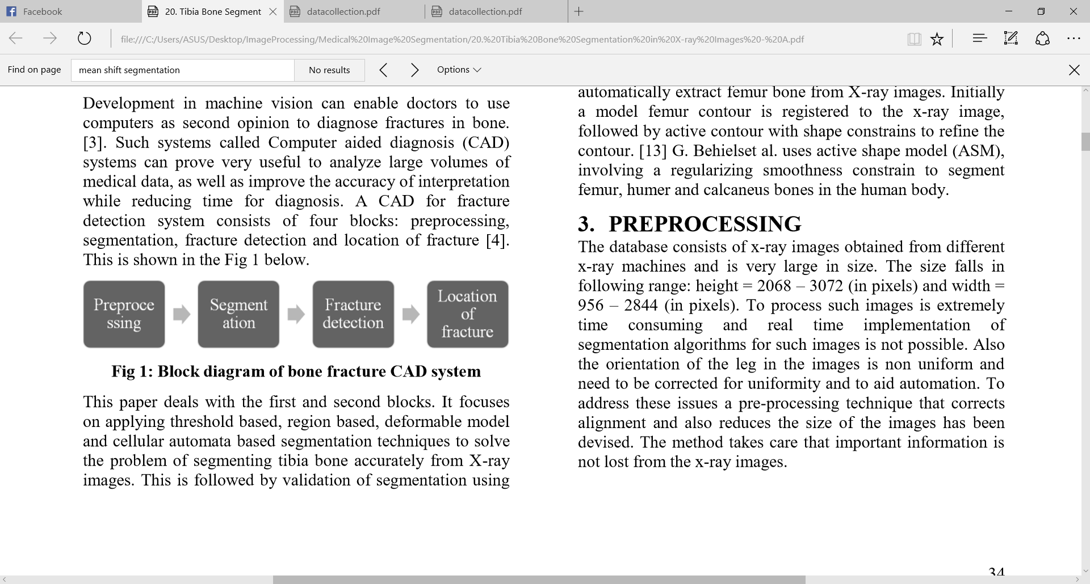

With the respect to this research is focused on Tibia bone segmentation in order to build a system which is called Computer aided diagnosis (CAD) for fracture detection of Tibia bone. In this work researchers have applied 5 different technique such as

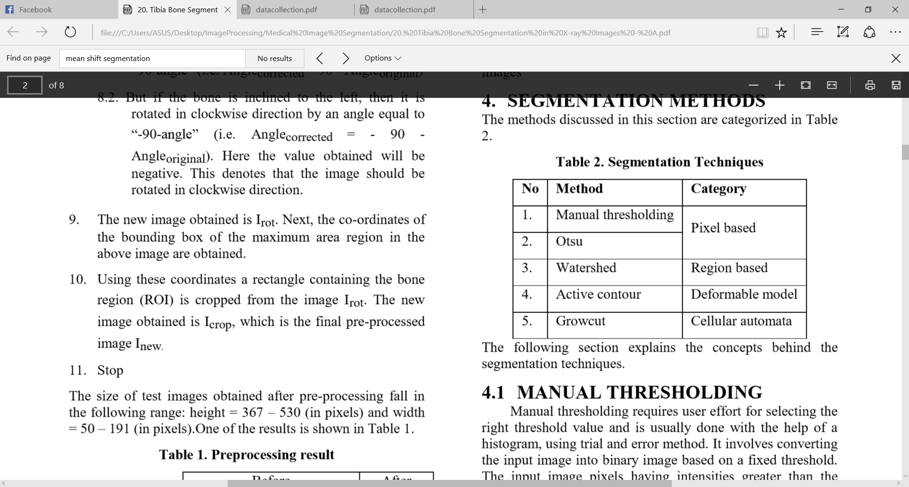

Deformable refer to  curves or surfaces defined within an image domain that provide an abstract model of an object class by modeling the variability separately in shape, texture or imaging conditions of the objects in the class.

**Research**

1. **Clustering vs Region Growing**

